Requesting from Archive

Go to Archives site <https://go.dhss.ak.local/dsds/archive/SitePages/Home.aspx>

Go to Archived Files

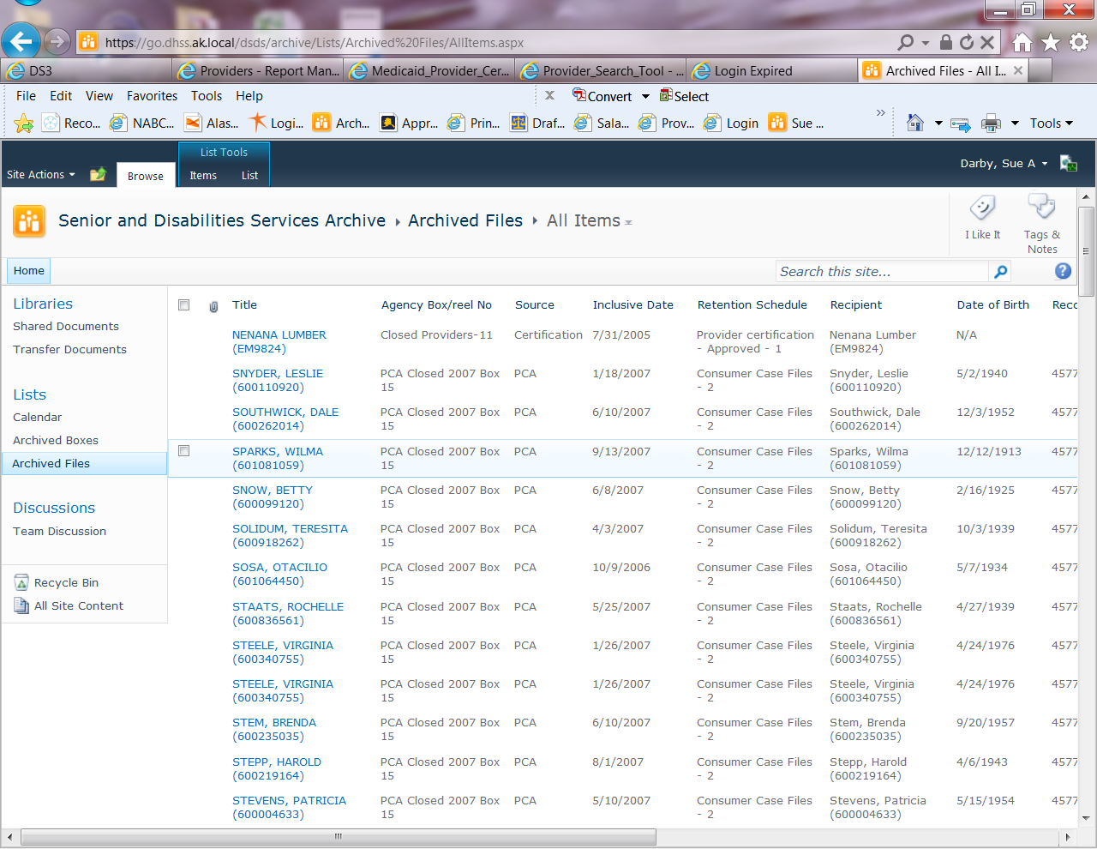

Search by provider number. If it is an older provider you can try the new number but if nothing is found check older numbers

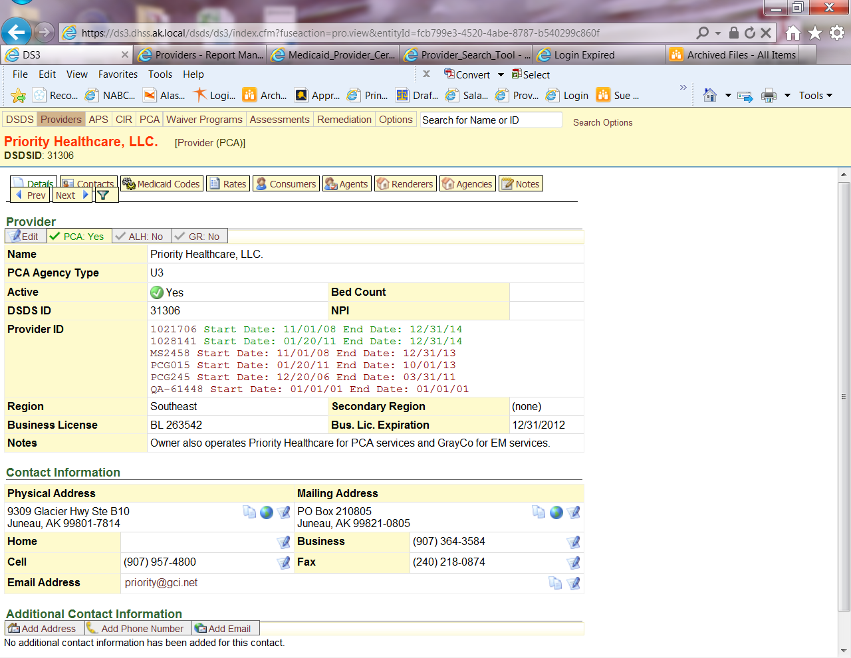

A good hint there is \*something\* in archives is to check the notes for ones that look like this:

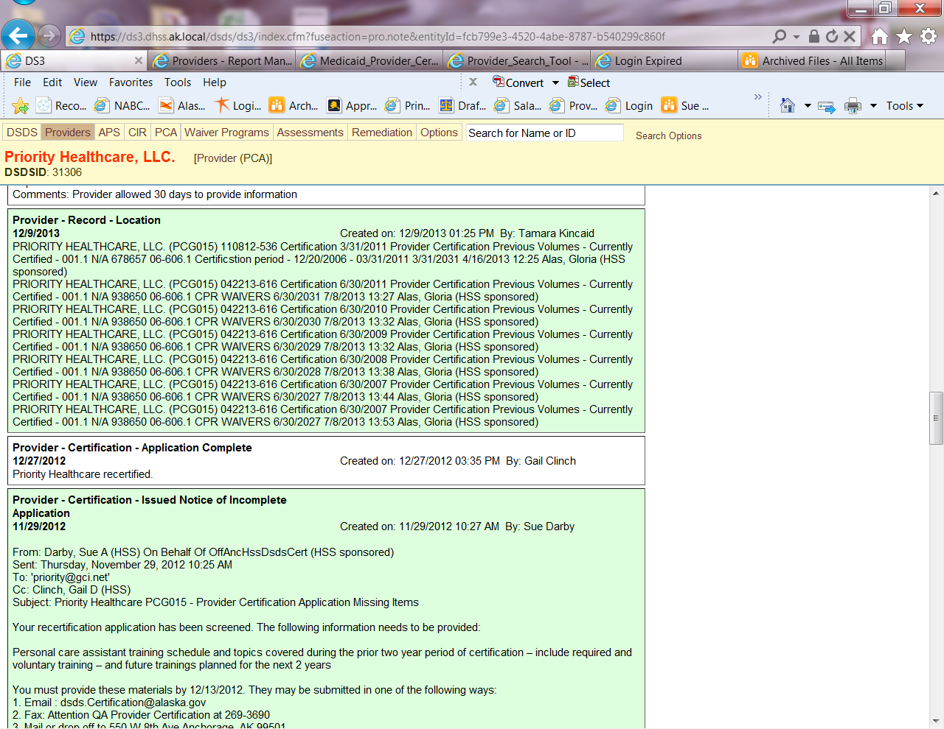

This can give clues to which number to search the Archive site with.

When you search you should get a list of results like this:

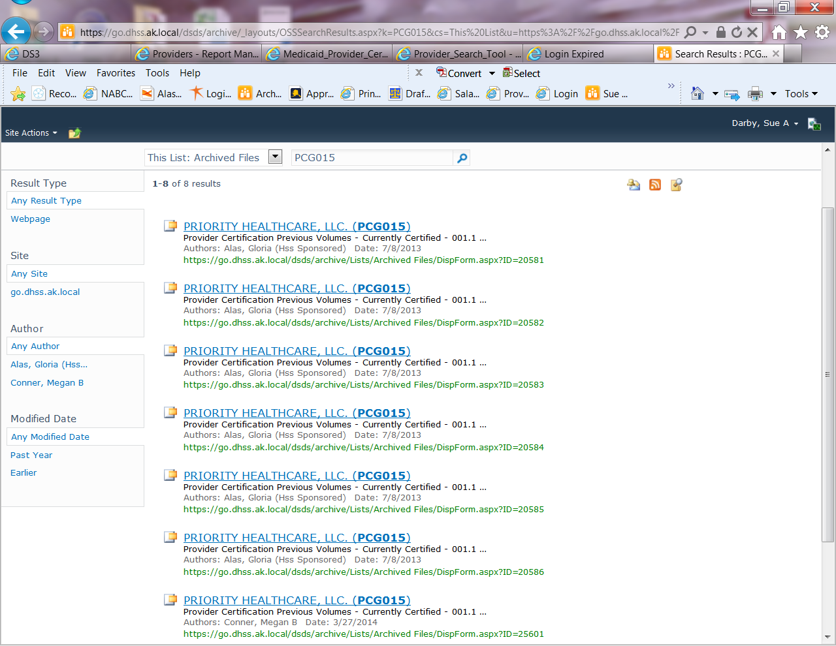

Each link above is one folder of information. Click on each one and usually there are notes as to what the file contains. Sometimes it is a certificaiton file and other times it is other information depending on the age of the provider.

To request a file from archives go into the result of choice:

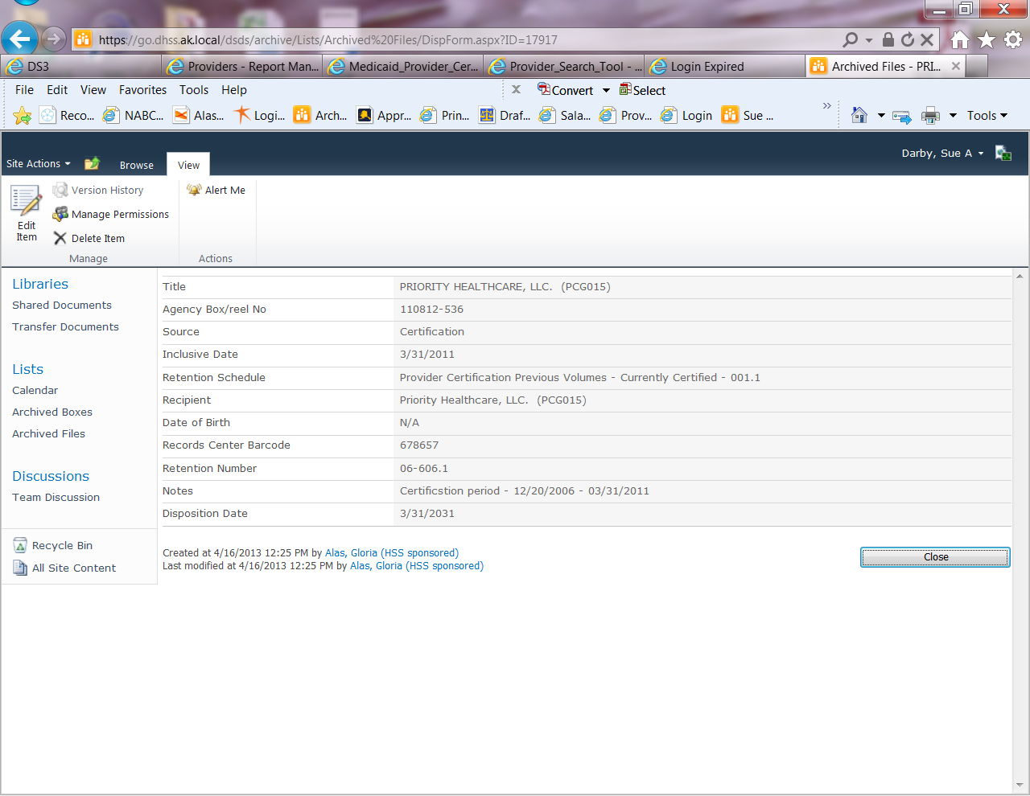

Copy and paste the following into an email to Tim Barnes or whomever is the Administrative Manager. Delete extra rows until you have the following information:

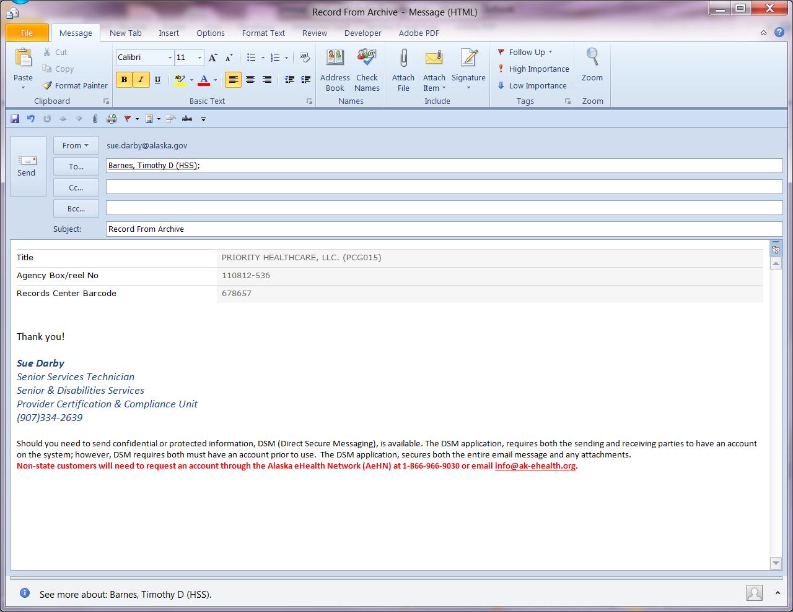

Archives does not want or need the rest of it. Add a simple note asking Tim to request the file ASAP and shortly afterwards you should get a confirmation back from him that it is ordered and then another phone call or email when it comes to the front desk.

Returning a file is easy, email Tim that you have files to go back and take them to the front desk for pick up.